4. Website Structure and Planning

4.1 Sitemap
The Modeling Academy website will contain nine main pages. The pages will be connected through a consistent navigation menu so that users can easily move between different sections of the website.
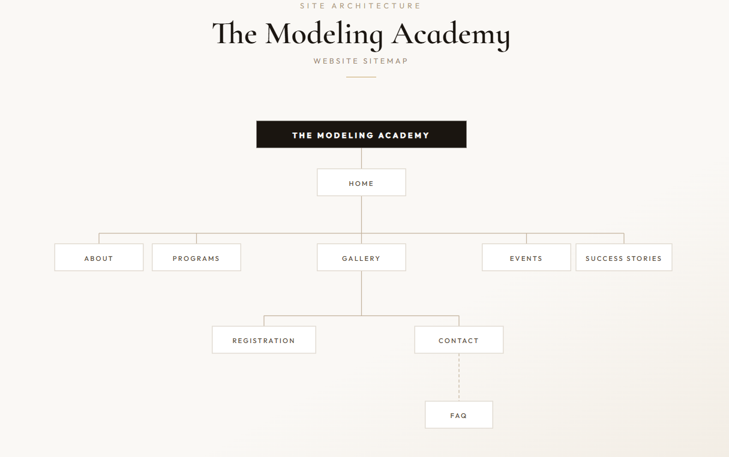

Wireframe

4.2 File and Folder Structure
The website will use a well-organised folder structure:
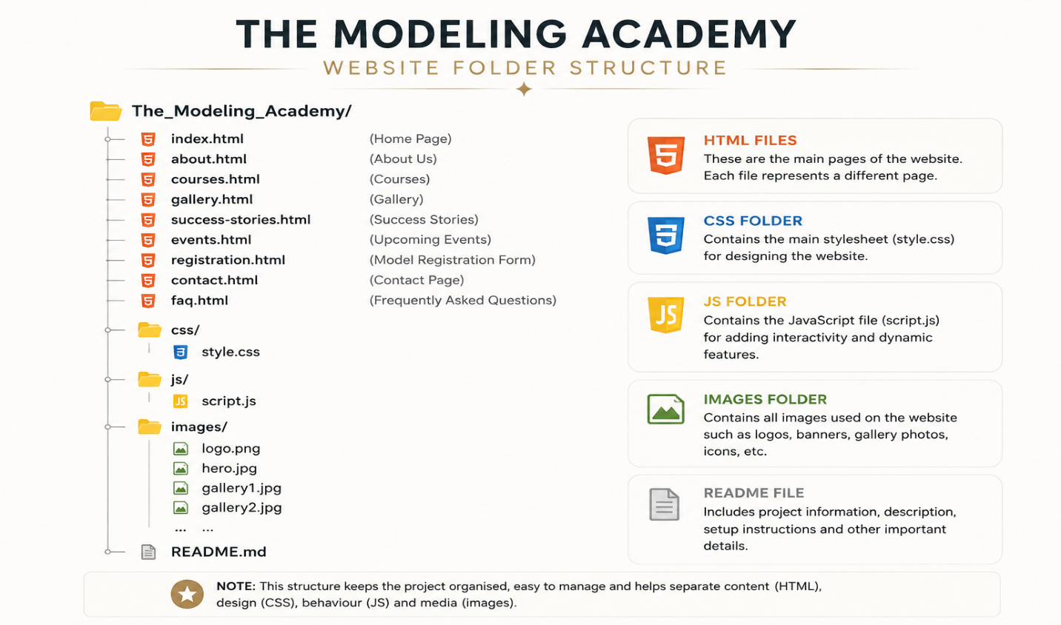
Figure 2:ChatGPT Image
The HTML files are stored in the root folder, while CSS, JavaScript and image files are placed in their own folders to keep the project organised and easier to maintain.

5. HTML Structure and Basic Content

5.1 HTML Files
Nine HTML files will be created for the website:
- index.html
- about.html
- programs.html
- gallery.html
- success-stories.html
- events.html
- registration.html
- contact.html
- faq.html
This meets the requirement of creating a minimum of five web pages.

5.2 Basic HTML Structure
Each webpage will use appropriate HTML5 elements such as <header>, <nav>, <main> and <footer> to organise the content. Headings, paragraphs, images, lists, forms and hyperlinks will also be used where appropriate.
For example, the navigation menu will contain links to all nine pages:
<nav>
<a href="index.html">Home</a>
<a href="about.html">About Us</a>
<a href="programs”.html">Courses</a>
<a href="gallery.html">Gallery</a>
<a href="success-stories.html">Success Stories</a>
<a href="events.html">Upcoming Events</a>
<a href="registration.html">Register</a>
<a href="contact.html">Contact</a>
<a href="faq.html">FAQ</a>
</nav>
Semantic HTML will be used to make the website structured, readable and easier to maintain.

5.3 Content Integration
The researched content about The Modeling Academy will be integrated into the HTML pages. The content will include information about the academy, its mission and vision, modelling courses, training activities, events, student success stories and contact information.
Appropriate HTML elements such as headings, paragraphs, lists, images and forms will be used to present the information clearly.

5.4 Navigation
A consistent navigation menu will be included across the website. HTML hyperlinks will connect the pages, allowing visitors to move between the Home, About Us, Courses, Gallery, Success Stories, Upcoming Events, Registration, Contact and FAQ pages.

5.5 Testing and Debugging
The website will be tested in different web browsers to check cross-browser compatibility. All navigation links, images, forms and page layouts will be checked to ensure that they work correctly.
HTML errors and other problems found during testing will be corrected before submission.

5.6 Comments
Comments will be included in the HTML, CSS and JavaScript code where necessary to explain important sections of the implementation. The code will also be properly indented and organised so that it is easy to read and understand.

6. GitHub Repository
A private GitHub repository will be created for The Modeling Academy website. The website files will be uploaded to the repository using a clear folder structure.
Changes to the website will be committed regularly using descriptive commit messages. Examples include:
- Initial website structure
- Added homepage and navigation
- Added courses and gallery pages
- Added registration form
- Added contact and FAQ pages
- Updated responsive CSS
- Fixed navigation links
- Final website testing
A README.md file will also be maintained in the repository. It will contain the project title, student information, project overview, website goals and objectives, key features, timeline and milestones, sitemap, Part 1 details, changelog and references.
The completed project will then be pushed to the remote GitHub repository and the repository link will be submitted as required.

